**🖎 LANGUAGES :**

**English : high degree " written and spoken "**

**🖎 COMPUTER SKILLS :**

**Net : General knowledge .**

**Other :,Word .Excel ,Autocad, Sap2000**

**1- work as a team member toward common goals.**

**2- able to work well with all levels of management & people**

* **Name : Assem Nan Saleeb**
* **Address : Assuit-dayrout**
* **Nationality : Egyptian**
* **Birth Place : Assuit**
* **Date Of Birth : 1 / 4 / 1984**
* **Marital Status : Single**
* **Military Service : Finished**
* **Mobile : 01220707477**
* **E-mail : engineerassem@yahoo.com**

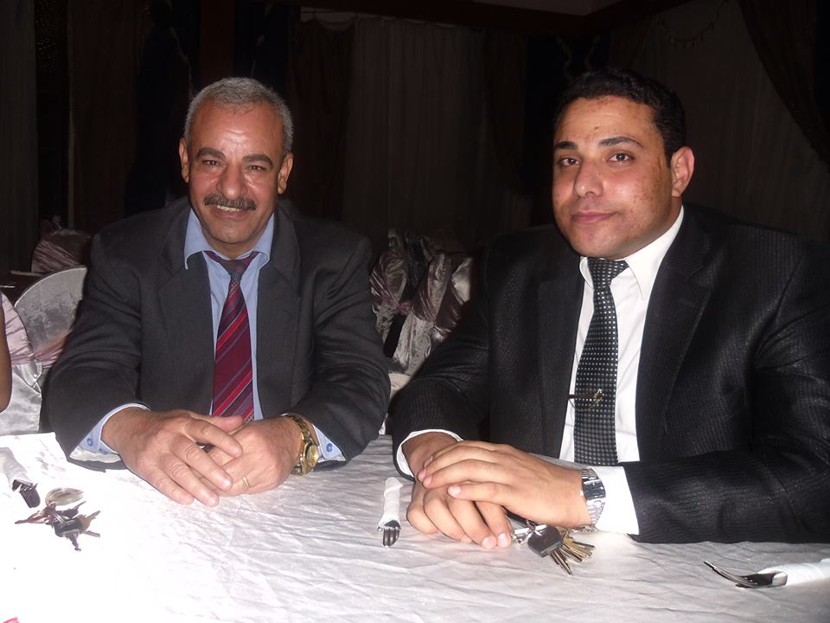

4